WorkShop 3 - Traffic Lights

# Group 4:

# Luca Novello

* **Vikor Makarov**

# 

Pseudocode

# Logic 3 - Pseudocode:

1. Start
2. Set the timer to 75- 80 sec.
3. Turn on red light
4. Is there an 'interrupt'?
   1. Yes: perform interrupt
   2. No: continue (step: 5)
5. Is duration < 10 sec?
   1. Yes: continue (step: 8)
   2. No: continue (step: 6)
6. Is the pedestrian button pressed?
   1. Yes: reduce timer to 10 sec (step: 8)
   2. No: continue (step: 8)
7. Are there > 5 cars?
   1. Yes: reduce timer to 10 sec (step: 8)
   2. No: continue (step: 8)
8. Is duration = 0?
   1. Yes: continue (step: 9)
   2. No: reduce by delta time and go to (step: 4)
9. Turn off the light
10. End

Red duration will be green light + amber light + 1-5 sec for safety for a total of 76 - 80 seconds.  
The program starts with the red light, which automatically reduces.

Flowcharts:

# Overall Flowchart:

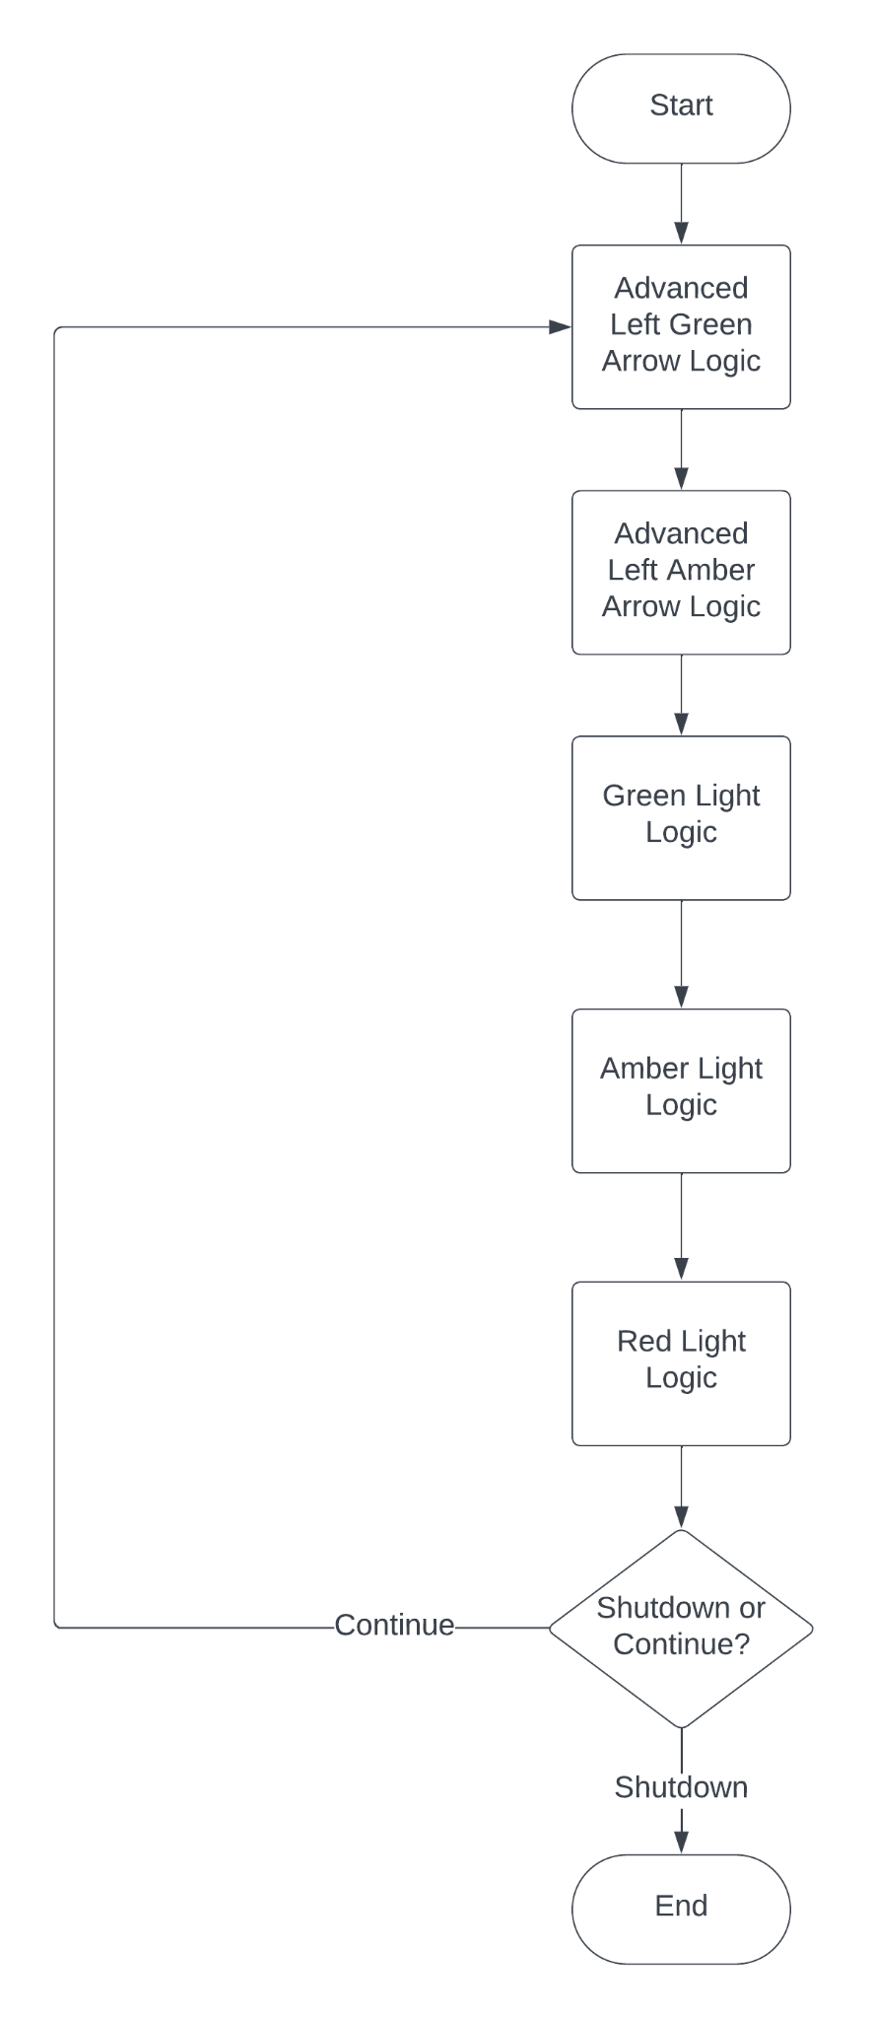

# Advanced Left Green Light Flowchart:

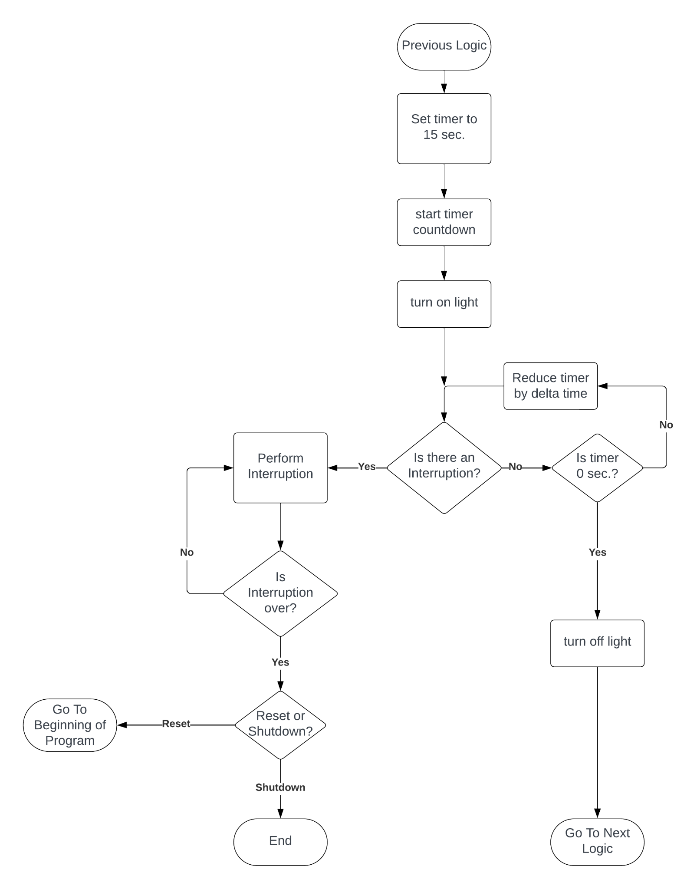

# Advanced Left Amber Light Flowchart:

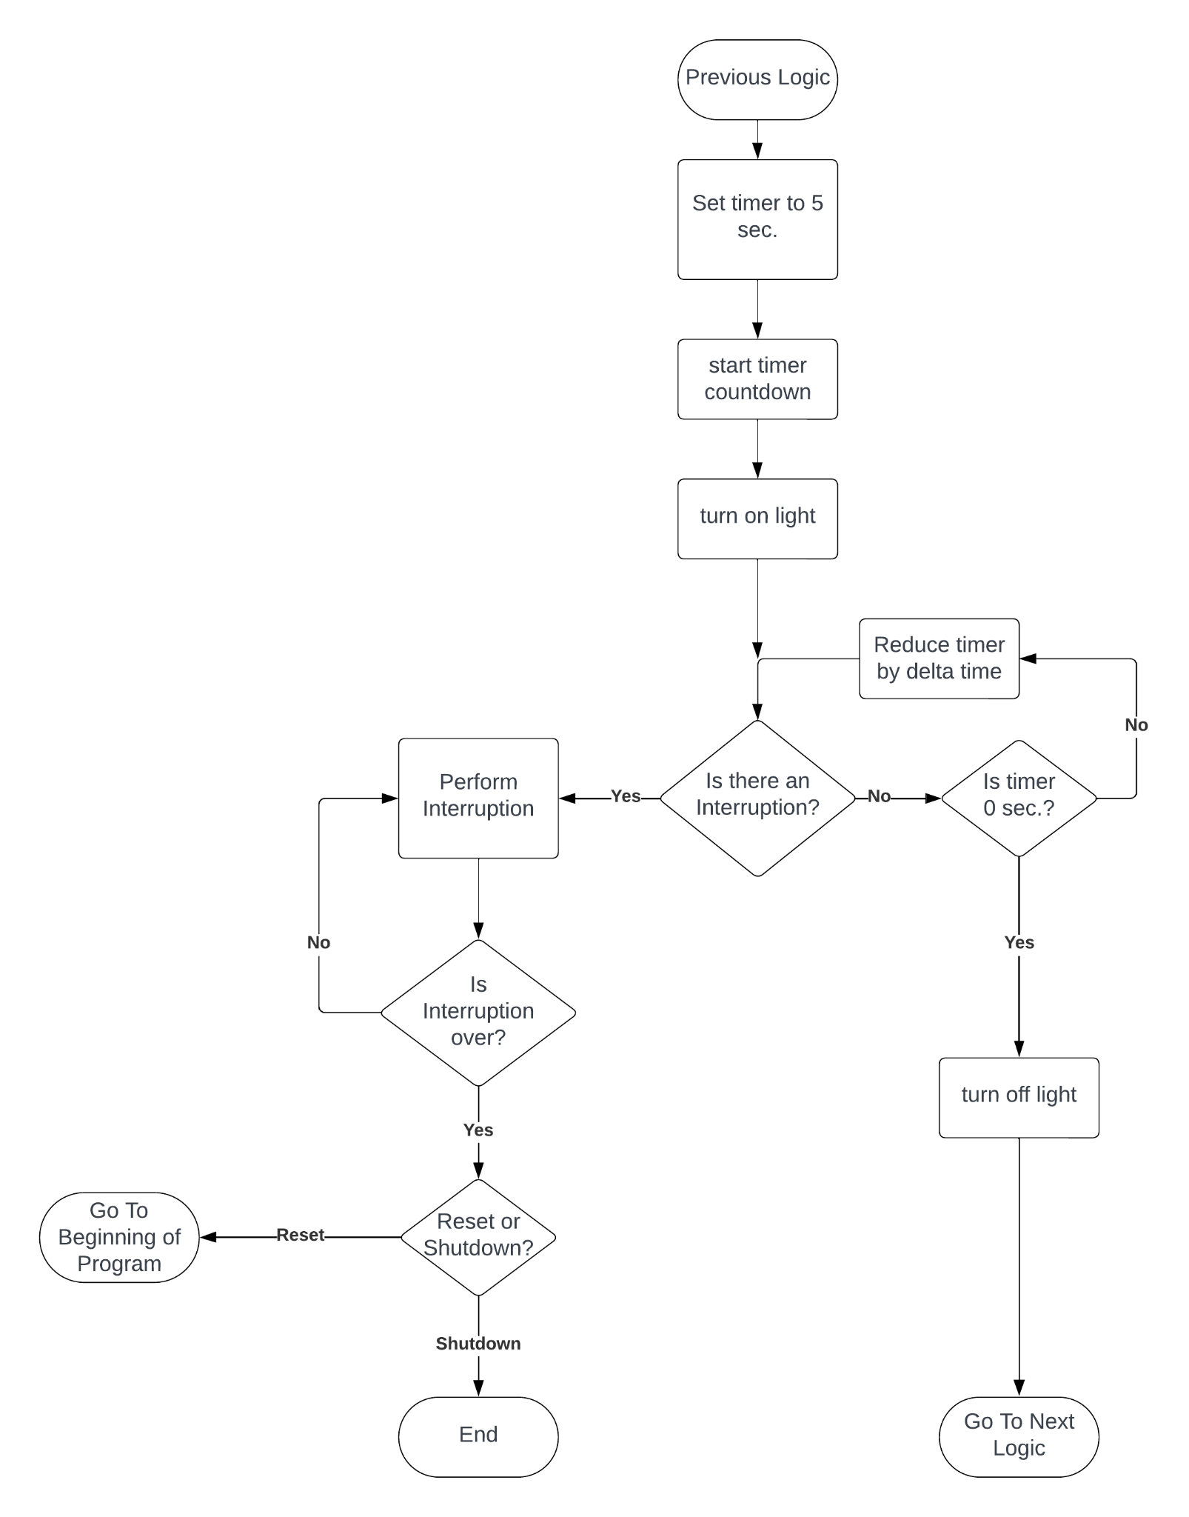

# Solid Green Light Flowchart:

# 

# 

# Solid Amber Light Flowchart:

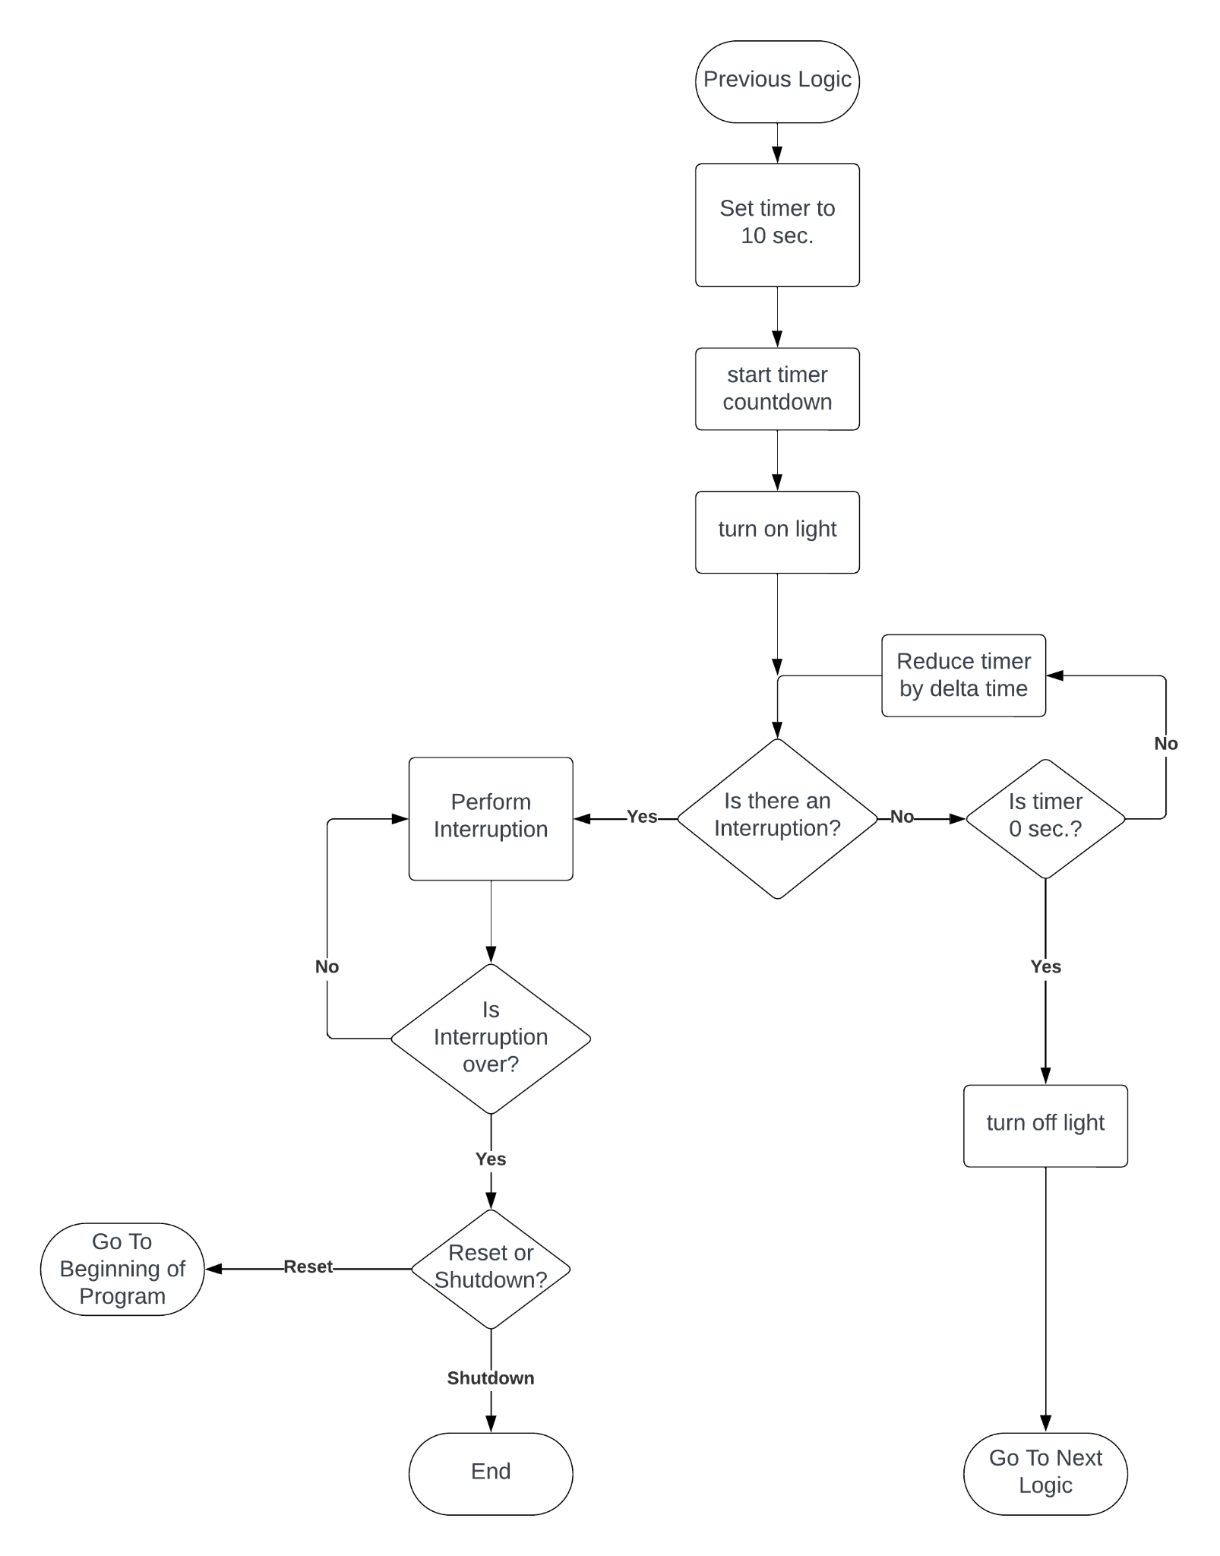

# Solid Red Light Flowchart:

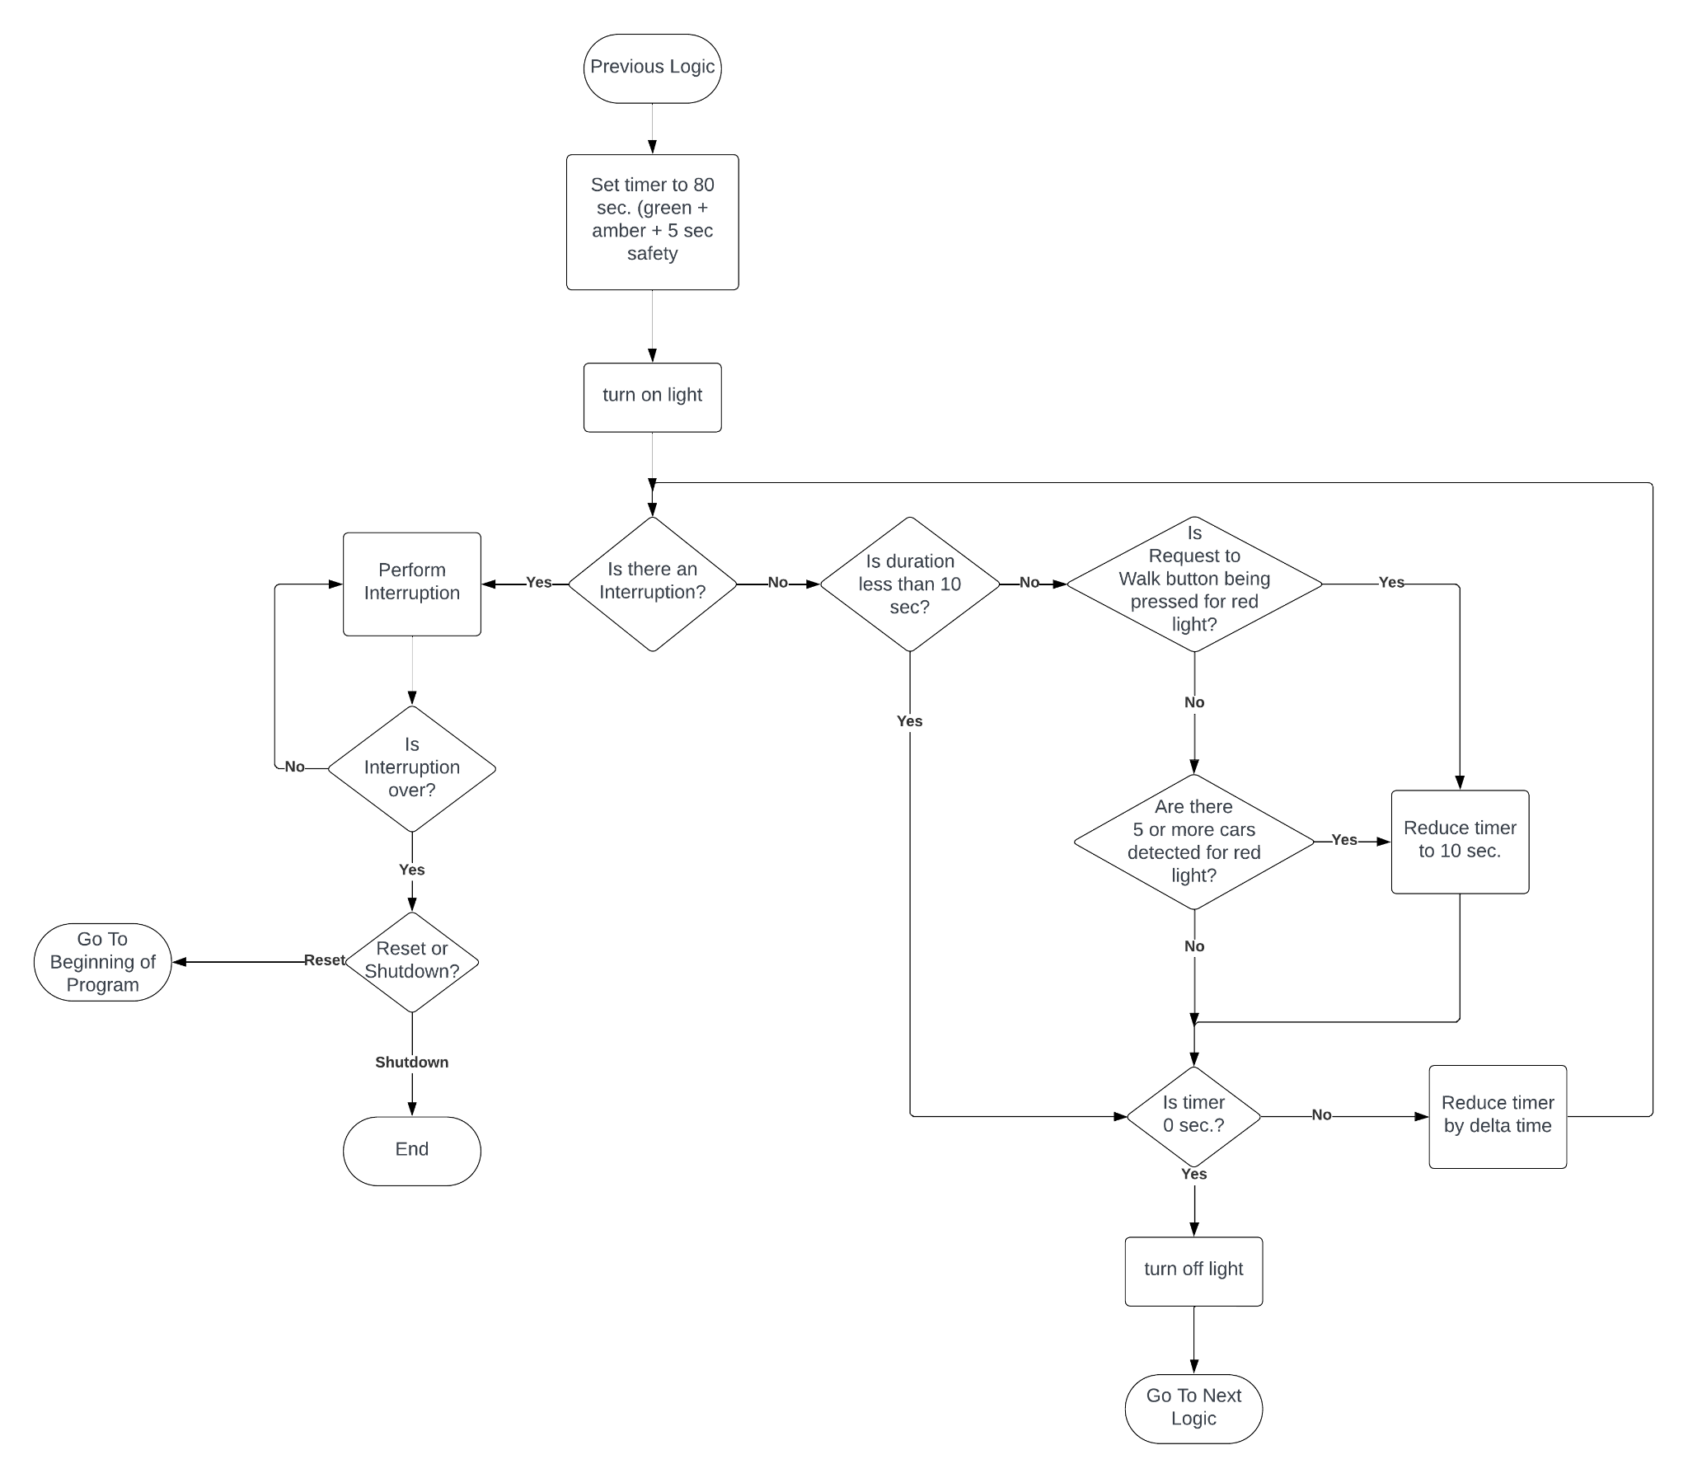

Test Logic

# Conditions:

* Solid red light
* More than 5 cars waiting
* No walk button pressed
* No interruptions
* Timer is 50 sec

# Test:

* Start
* Set timer
* Is there any interruption?
* No
* Is the duration less than 20 sec.
* No
* Is the walk button pressed?
* No
* Is there more than 5 cars waiting?
* Yes
* Reduce timer to 10 sec
* Has the timer reached 0 sec?
* No
* Reduce timer by delta time
* Go back to “Reduce timer to 10 sec” and repeat until timer has reached 0 sec.

Final Description

The traffic light algorithm uses the same process for the solid green and red lights and a similar algorithm for the solid amber and advanced arrow lights,but removes the need to check for the walk button and car sensor. The timer function involved in setting the duration of the light is assumed to be a separate function, and will count down to 0 on its own. The red light adds an extra second to the timer for safety. Each step initially checks for an interruption, if there is an interruption, it will process the interruption, or else it will proceed with the light algorithm. The walk button and car sensor time reduction will only be checked during the red light phase and if there is less than 20 seconds left for the amber light (10 sec) and an additional 10 seconds needs to be on the timer to reduce it by. The solid green and advanced green arrow light will start together. The advanced lights will end before the solid green light (even with the reduced time from the walk button/car sensor), and then the solid green light will transition into the amber light and then the red light. Once the red light is complete, the program restarts.